Work Life Balance
General Information
Work-life balance is the ability to separate liabilities between work and particular life. With this type of management, individuals can effectively manage their particular commitments without one area negatively impacting the other.
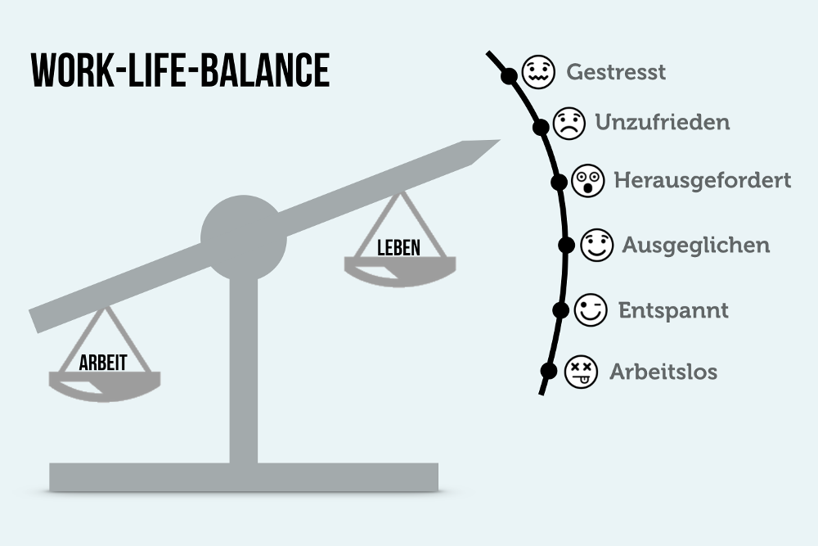
Why is it necessary?
It’s very important, when you want to prevent physical and mental issues. Without the right work-life balance, individuals can end up of having a burnout or depression. It allows you to pursue particular pretensions and interests, spend time with loved ones , and take care of your wellbeing, while also fulfilling your professional liabilities.
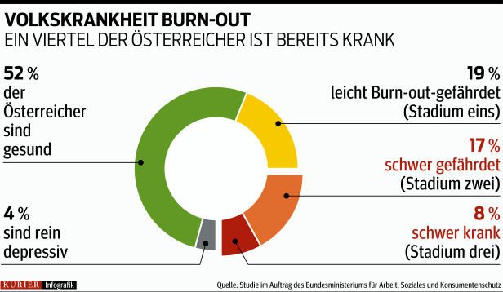
- 1,36 Million people: Burnout stadium 1 or 2
- 600 000 people: Burnout stadium 3
How to achieve a good work-life-balance
To achieve a good work-life balance, it’s important to set a strict line between work and particular time. For example, this means that you don’t accept a call from the office during your free time, or check your mails.
Another essential thing to do in terms of achieving a good work-life balance is to manage your time. Managing every single hour of your work can boost your productivity and get your work done efficiently.

